**cv. 05 - Porovnanie QoS mechanizmov**

**Kováč, Kurnas**

**1. Preskúmajte hardvérový front smerovača**

**a. Čo vieme z prednášky:**

**i. Smerovače určujú veľkosť hardvérového frontu rozhrania automaticky na základe konfigurovanej prenosovej kapacity (bandwidth)**

**ii. Veľkosť hardvérového frontu je možné priamo konfigurovať na rozhraní príkazom tx-ring-limit**

**b. Zmeňte rýchlosť sériovej linky a odsledujte či a ako sa zmení HW front TxRing pre dané rozhranie - konkrétne sledujeme jeho veľkosť (môže robiť každý na svojom smerovači na výstupnom rozhraní):**

**i. show controllers s0/0/...**

Príkaz **show controllers** uvádza veľkosť hardvérového frontu zvoleného rozhrania

R1#sh controllers s0/0/0

tx_limited = 0(128), errata19 count1 - 0, count2 – 0

Pri zmene bandwithu a clock rate-u na interface-i sa hodnota tx_limited nezmenila.

Zmenu dosiahneme pomocou príkazu tx-ring-limit na konkrétnom interface-i:

R1#int s0/0/0

R1(config-if)#tx-ring-limit 20

R1#sh controllers s0/0/0

...

tx_limited = 0(20), errata19 count1 - 0, count2 – 0

**2. Preskúmajte defaultné nastavenia WFQ**

**a. Zapnite WFQ na sériovom rozhraní a nastavte kapacitu linky na 128kbps**

R2(config)#policy-map WFQ

R2(config-pmap)#class class-default

R2(config-pmap-c)#fair-queue

R2(config)#int s0/0/0

R2(config-if)#service-policy output WFQ

R2(config-if)#bandwidth 128

Keď sme zapli WFQ politiku, tak sa hodnota tx_limited zmenila na 1(2)

R2#sh controllers s0/0/0

Interface Serial0/0/0

Hardware is GT96K

DTE V.35 TX and RX clocks detected.

idb at 0x6918200C, driver data structure at 0x691834A0

wic_info 0x69183AD4

Physical Port 0, SCC Num 0

MPSC Registers:

MMCR_L=0x000304C0, MMCR_H=0x00000000, MPCR=0x00000000

CHR1=0x00FE007E, CHR2=0x00000000, CHR3=0x0000064A, CHR4=0x00000000

CHR5=0x00000000, CHR6=0x00000000, CHR7=0x00000000, CHR8=0x00000000

CHR9=0x00000000, CHR10=0x00003008

SDMA Registers:

SDC=0x00002201, SDCM=0x00000080, SGC=0x0000C000

CRDP=0x165DF8C0, CTDP=0x165DFAF0, FTDB=0x165DFAF0

Main Routing Register=0x0003FE38 BRG Conf Register=0x00480000

Rx Clk Routing Register=0x76543818 Tx Clk Routing Register=0x76543219

GPP Registers:

Conf=0x30002 , Io=0x6C050 , Data=0x7F1BBFA9, Level=0x180000

Conf0=0x30002 , Io0=0x6C050 , Data0=0x7F1BBFA9, Level0=0x180000

0 input aborts on receiving flag sequence

0 throttles, 0 enables

0 overruns

0 transmitter underruns

0 transmitter CTS losts

650 rxintr, 650 txintr, 0 rxerr, 0 txerr

1306 mpsc_rx, 0 mpsc_rxerr, 0 mpsc_rlsc, 6 mpsc_rhnt, 1297 mpsc_rfsc

10 mpsc_rcsc, 0 mpsc_rovr, 0 mpsc_rcdl, 0 mpsc_rckg, 0 mpsc_bper

0 mpsc_txerr, 573 mpsc_teidl, 0 mpsc_tudr, 0 mpsc_tctsl, 0 mpsc_tckg

0 sdma_rx_sf, 0 sdma_rx_mfl, 0 sdma_rx_or, 0 sdma_rx_abr, 0 sdma_rx_no

0 sdma_rx_de, 0 sdma_rx_cdl, 0 sdma_rx_ce, 0 sdma_tx_rl, 0 sdma_tx_ur, 0 sdma_tx_ctsl

0 sdma_rx_reserr, 0 sdma_tx_reserr

0 rx_bogus_pkts, rx_bogus_flag FALSE

0 sdma_tx_ur_processed

tx_limited = 1(2), errata19 count1 - 0, count2 - 0

Receive Ring

rxr head (2)(0x165DF8C0), rxr tail (0)(0x165DF8A0)

rmd(165DF8A0): nbd 165DF8B0 cmd_sts 80800000 buf_sz 06000000 buf_ptr 165E6320

rmd(165DF8B0): nbd 165DF8C0 cmd_sts 80800000 buf_sz 06000000 buf_ptr 165E5000

...

rmd(165DFA90): nbd 165DF8A0 cmd_sts 80800000 buf_sz 06000000 buf_ptr 165E49A0

Transmit Ring

txr head (2)(0x165DFB00), txr tail (2)(0x165DFB00)

tmd(165DFAE0): nbd 165DFAF0 cmd_sts 00C30000 byt_cnt ABCDABCD buf_ptr 1664B0D4

tmd(165DFAF0): nbd 165DFB00 cmd_sts 00C30000 byt_cnt ABCDABCD buf_ptr 1664B354

tmd(165DFB00): nbd 165DFB10 cmd_sts 00C30000 byt_cnt ABCDABCD buf_ptr 0

tmd(165DFB10): nbd 165DFB20 cmd_sts 00C30000 byt_cnt ABCDABCD buf_ptr 0

tmd(165DFB20): nbd 165DFB30 cmd_sts 00C30000 byt_cnt ABCDABCD buf_ptr 0

...

buffer size 1524

Keď sme použili príkaz tx-ring-limit: 5000, tak tx_limited = 1(5000)

**b. Zistite (show interface s0/0..) aké sú hodnoty pre:**

**i. CDT (congestive discard threshhold)**

**ii. Hold-queue**

**iii. Max. počet front ktoré automaticky vytvára a indexuje do nich prichádzajúe pakety (Conversations...)**

R2#show interface s0/0/0

Serial0/0/0 is up, line protocol is up

Hardware is GT96K Serial

Internet address is 10.0.12.2/24

MTU 1500 bytes, BW 128 Kbit/sec, DLY 20000 usec,

reliability 255/255, txload 1/255, rxload 1/255

Encapsulation HDLC, loopback not set

Keepalive set (10 sec)

Last input 00:00:03, output 00:00:00, output hang never

Last clearing of "show interface" counters never

Input queue: 0/75/0/0 (size/max/drops/flushes); Total output drops: 0

Queueing strategy: Class-based queueing

Output queue: 0/1000/0 (size/max total/drops)

5 minute input rate 0 bits/sec, 0 packets/sec

5 minute output rate 0 bits/sec, 0 packets/sec

764 packets input, 52273 bytes, 0 no buffer

Received 739 broadcasts (0 IP multicasts)

0 runts, 0 giants, 0 throttles

0 input errors, 0 CRC, 0 frame, 0 overrun, 0 ignored, 0 abort

765 packets output, 52619 bytes, 0 underruns

0 output errors, 0 collisions, 4 interface resets

0 unknown protocol drops

0 output buffer failures, 0 output buffers swapped out

6 carrier transitions

DCD=up DSR=up DTR=up RTS=up CTS=up

CDT nezobrazuje na routroch s novším OS.

Hold-queue = 0

Max. počet front, ktoré automaticky vytvára a indexuje do nich prichádzajúe pakety = 1000

**Monitoring WFQ**

Zobrazenie int s0/0/0

Na novších OS je podporovaná queuing strategy: class-based queuing

**d. Pokúste sa zmeniť jednotlivé hodnoty pre hold-queue aj max. počet front**

Hodnota hold-queue sa nedá meniť, pretože to je celkový počet paketov vo WFQ systéme.

Hodnota max. počet vo fronte sa dá zmeniť na potrebnú hodnotu pomocou príkazu hold-queue na int s0/0/0

R2#interface s0/0/0

R2(config-if)#hold-queue 500 out

R2(config-if)#do sh interface s0/0/0

Serial0/0/0 is up, line protocol is up

Hardware is GT96K Serial

Internet address is 10.0.12.2/24

MTU 1500 bytes, BW 128 Kbit/sec, DLY 20000 usec,

reliability 255/255, txload 1/255, rxload 1/255

Encapsulation HDLC, loopback not set

Keepalive set (10 sec)

Last input 00:00:02, output 00:00:09, output hang never

Last clearing of "show interface" counters never

Input queue: 0/75/0/0 (size/max/drops/flushes); Total output drops: 0

Queueing strategy: Class-based queueing

Output queue: 0/500/0 (size/max total/drops)

5 minute input rate 0 bits/sec, 0 packets/sec

5 minute output rate 0 bits/sec, 0 packets/sec

909 packets input, 63274 bytes, 0 no buffer

Received 884 broadcasts (0 IP multicasts)

0 runts, 0 giants, 0 throttles

0 input errors, 0 CRC, 0 frame, 0 overrun, 0 ignored, 0 abort

908 packets output, 63245 bytes, 0 underruns

0 output errors, 0 collisions, 4 interface resets

0 unknown protocol drops

0 output buffer failures, 0 output buffers swapped out

6 carrier transitions

DCD=up DSR=up DTR=up RTS=up CTS=up

**3. Experimenty s FIFO, PQ a WFQ**

**i. Zaznamenávajte straty a oneskorenia cez D-ITG (logger)**

**ii. FIFO, PQ a WFQ sú dostupné aj na novších IOSoch, CQ už nie (preto na novších IOSoch sa CQ nepokúšať testovať, iba ostatné tri)**

**FIFO**

Prvý pokus:

Tok dlhý 30s. Dĺžka (veľkosť) paketov 500 B.

Generovali sme dva toky po 10 p/s, aby šli pod kapacitu linky. Druhý tok má oneskorenie 10 s.

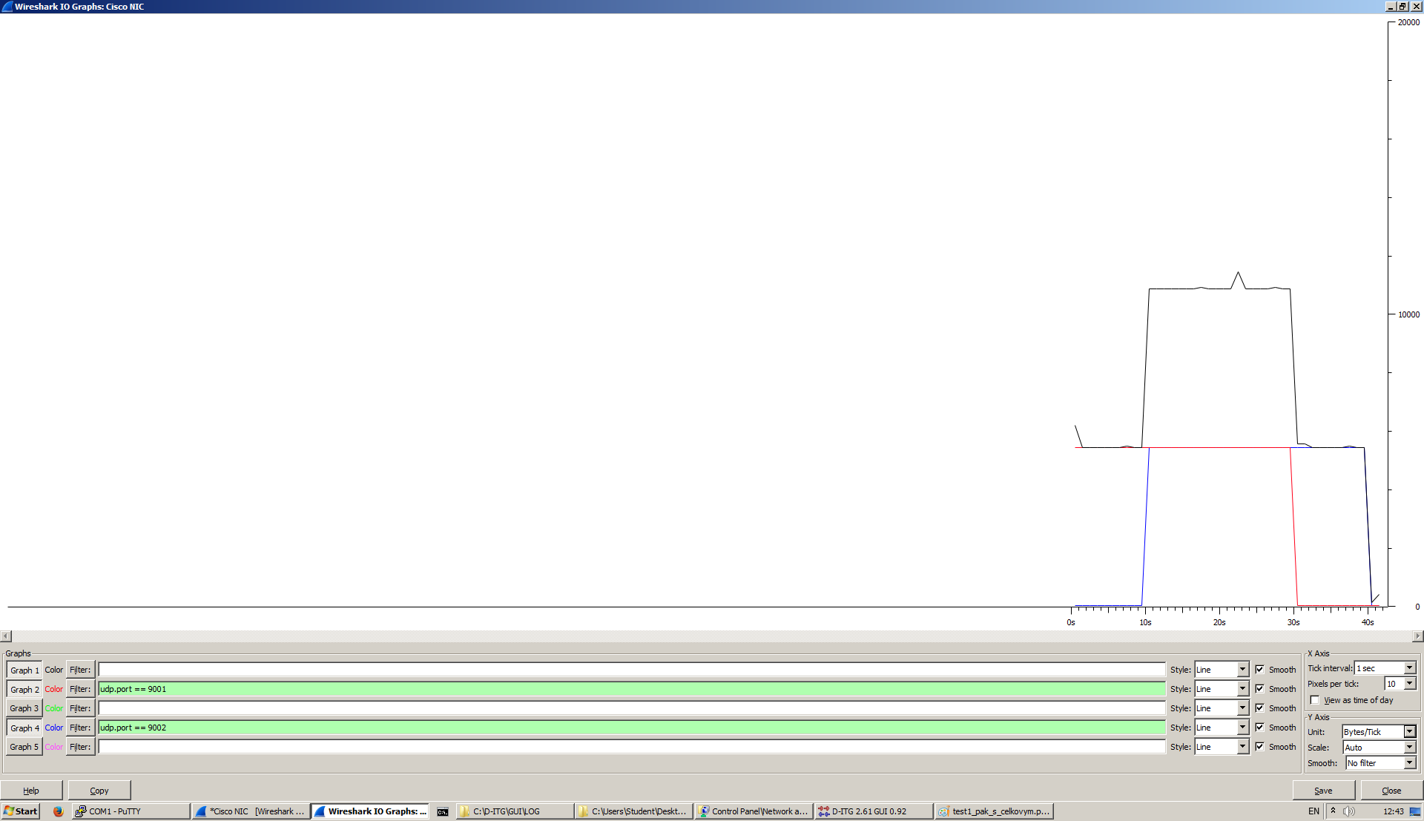

__________________________________________________________

**************** TOTAL RESULTS ******************

__________________________________________________________

Number of flows = 2

Total time = 39.877000 s

Total packets = 600

Minimum delay = -19.422000 s

Maximum delay = -19.198000 s

Average delay = -19.312213 s

Average jitter = 0.003933 s

Delay standard deviation = 0.107861 s

Bytes received = 300000

Average bitrate = 60.185069 Kbit/s

Average packet rate = 15.046267 pkt/s

Packets dropped = 0 (0.00 %)

Average loss-burst size = 0 pkt

Error lines = 0

----------------------------------------------------------

Druhý pokus:

Generovali sme dva toky jeden 15 p/s a druhý 20 p/s, aby sme išli nad kapacitou linky.

Dĺžka (veľkosť) paketov 800 B; druhý tok s oneskorením 10 s.

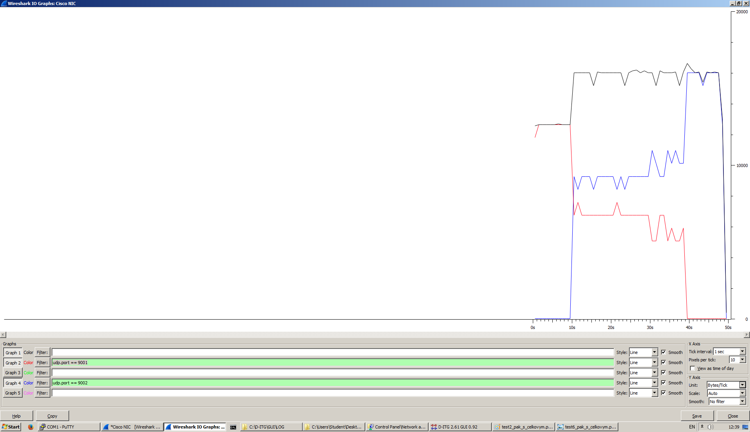

__________________________________________________________

**************** TOTAL RESULTS ******************

__________________________________________________________

Number of flows = 2

Total time = 48.693000 s

Total packets = 881

Minimum delay = -19.275000 s

Maximum delay = -10.335000 s

Average delay = -13.774310 s

Average jitter = 0.033411 s

Delay standard deviation = 3.580817 s

Bytes received = 704800

Average bitrate = 115.794878 Kbit/s

Average packet rate = 18.092950 pkt/s

Packets dropped = 168 (16.02 %)

Average loss-burst size = 2.048780 pkt

Error lines = 0

----------------------------------------------------------

**Konfigurácia a testovanie stratégie Priority Queuing**

access-list 101 permit udp any any eq 9001  
access-list 102 permit udp any any eq 9002

class-map match-all tok1  
 match access-group 101  
class-map match-all tok2  
 match access-group 102  
class-map match-all pri2  
 match access-group 102  
class-map match-all pri1  
 match access-group 101  
  
policy-map qos  
 class pri1  
 priority level 1  
 class pri2  
 priority level 2  
policy-map znacka  
 class tok1  
 set dscp af11  
 class tok2  
 set dscp af21

Aplikovanie značkovania na f0/0: service policy input znacka

Aplikovanie QOS na s0/0/0: service policy output qos

prvý pokus:

Tok dlhý 30s; dĺžka (veľkosť) paketov 500 B.

Generovali sme dva toky po 10 p/s, aby sme išli pod kapacitou linky.

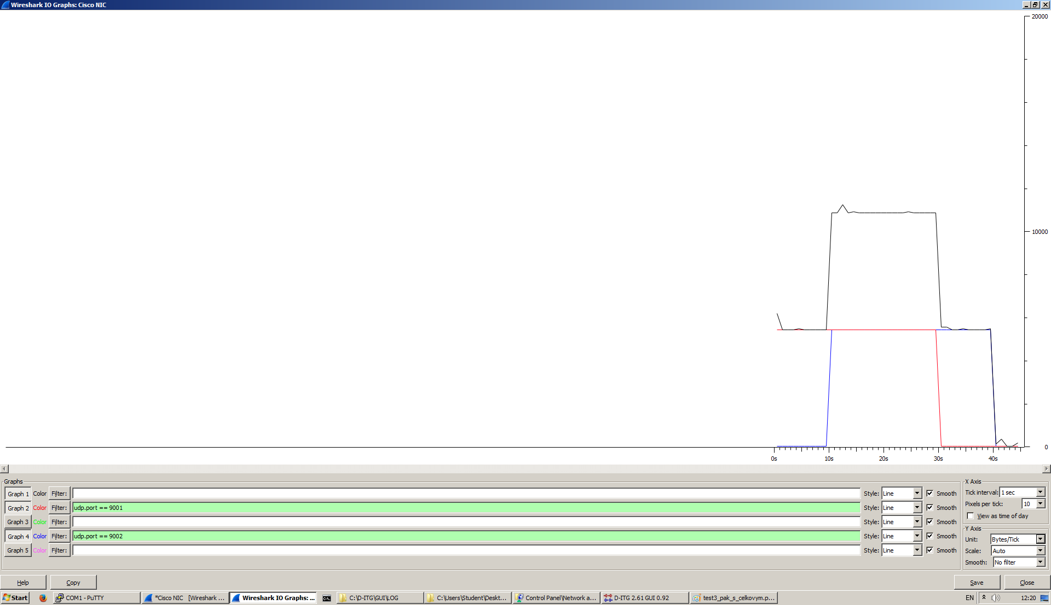

Druhý pokus:

Dĺžka (veľkosť) paketov 800 B; druhý tok oneskorenie 10 s.

Generovali sme dva toky jeden 15 p/s a druhý 20 p/s, aby sme išli nad kapacitou linky.

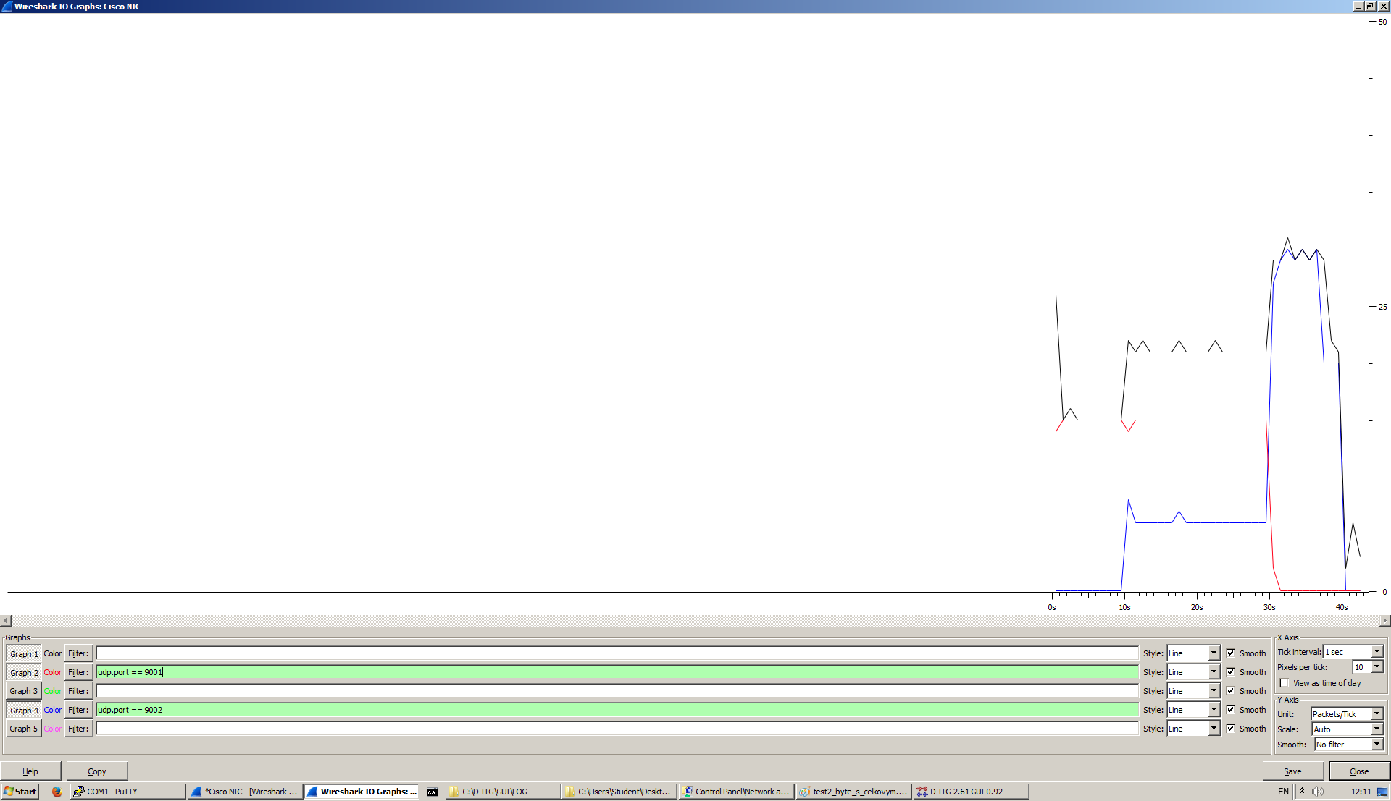

----------------------------------------------------------

Flow number: 1

From 10.0.1.2:62937

To 10.0.2.2:9001

----------------------------------------------------------

Total time = 30.024000 s

Total packets = 450

Minimum delay = -19.211000 s

Maximum delay = -19.110000 s

Average delay = -19.154622 s

Average jitter = 0.011176 s

Delay standard deviation = 0.039866 s

Bytes received = 360000

Average bitrate = 95.923261 Kbit/s

Average packet rate = 14.988010 pkt/s

Packets dropped = 0 (0.00 %)

Average loss-burst size = 0.000000 pkt

----------------------------------------------------------

----------------------------------------------------------

Flow number: 2

From 10.0.1.2:62938

To 10.0.2.2:9002

----------------------------------------------------------

Total time = 29.929000 s

Total packets = 387

Minimum delay = -19.227000 s

Maximum delay = -8.428000 s

Average delay = -15.666297 s

Average jitter = 0.057951 s

Delay standard deviation = 3.690875 s

Bytes received = 193500

Average bitrate = 51.722410 Kbit/s

Average packet rate = 12.930602 pkt/s

Packets dropped = 213 (35.50 %)

Average loss-burst size = 2.290323 pkt

----------------------------------------------------------

__________________________________________________________

**************** TOTAL RESULTS ******************

__________________________________________________________

Number of flows = 2

Total time = 39.895000 s

Total packets = 837

Minimum delay = -19.227000 s

Maximum delay = -8.428000 s

Average delay = -17.541741 s

Average jitter = 0.070982 s

Delay standard deviation = 3.053576 s

Bytes received = 553500

Average bitrate = 110.991352 Kbit/s

Average packet rate = 20.980073 pkt/s

Packets dropped = 213 (20.29 %)

Average loss-burst size = 2.290323 pkt

Error lines = 0

----------------------------------------------------------

**Konfigurácia a testovanie stratégie WFQ**

policy-map WFQ

class class-default

fair-queue

Na s0/0/0 vypneme policy mapu QOS a aktivujeme policy mapu WFQ:

service policy output WFQ

Prvý pokus:

Tok dlhý 30s; dĺžka (veľkosť) paketov 500 B.

Generovali sme dva toky po 10 p/s, aby sme išli pod kapacitou linky.

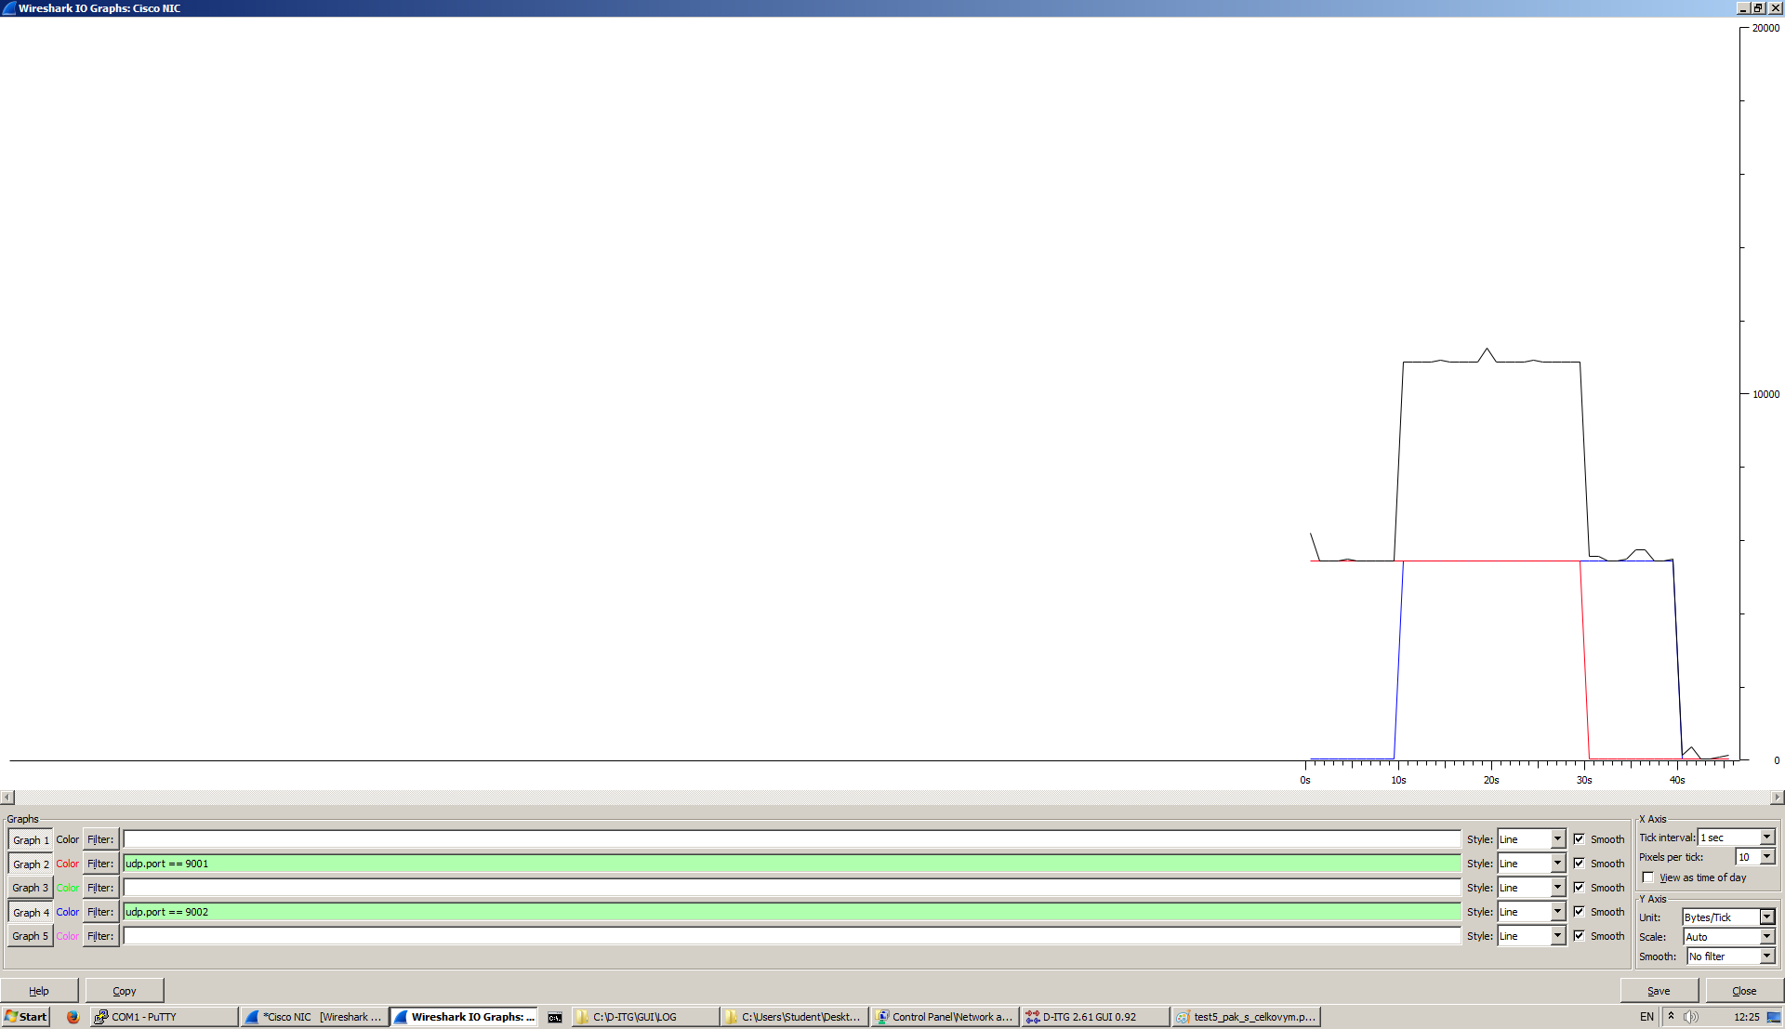

__________________________________________________________

**************** TOTAL RESULTS ******************

__________________________________________________________

Number of flows = 2

Total time = 39.863000 s

Total packets = 600

Minimum delay = -19.295000 s

Maximum delay = -19.271000 s

Average delay = -19.291940 s

Average jitter = 0.000770 s

Delay standard deviation = 0.001650 s

Bytes received = 300000

Average bitrate = 60.206206 Kbit/s

Average packet rate = 15.051552 pkt/s

Packets dropped = 0 (0.00 %)

Average loss-burst size = 0 pkt

Error lines = 0

----------------------------------------------------------

Druhý pokus:

Dĺžka (veľkosť) paketov 800 B; druhý tok oneskorenie 10 s.

Generovali sme dva toky jeden 15 p/s a druhý 20 p/s, aby sme išli nad kapacitou linky.

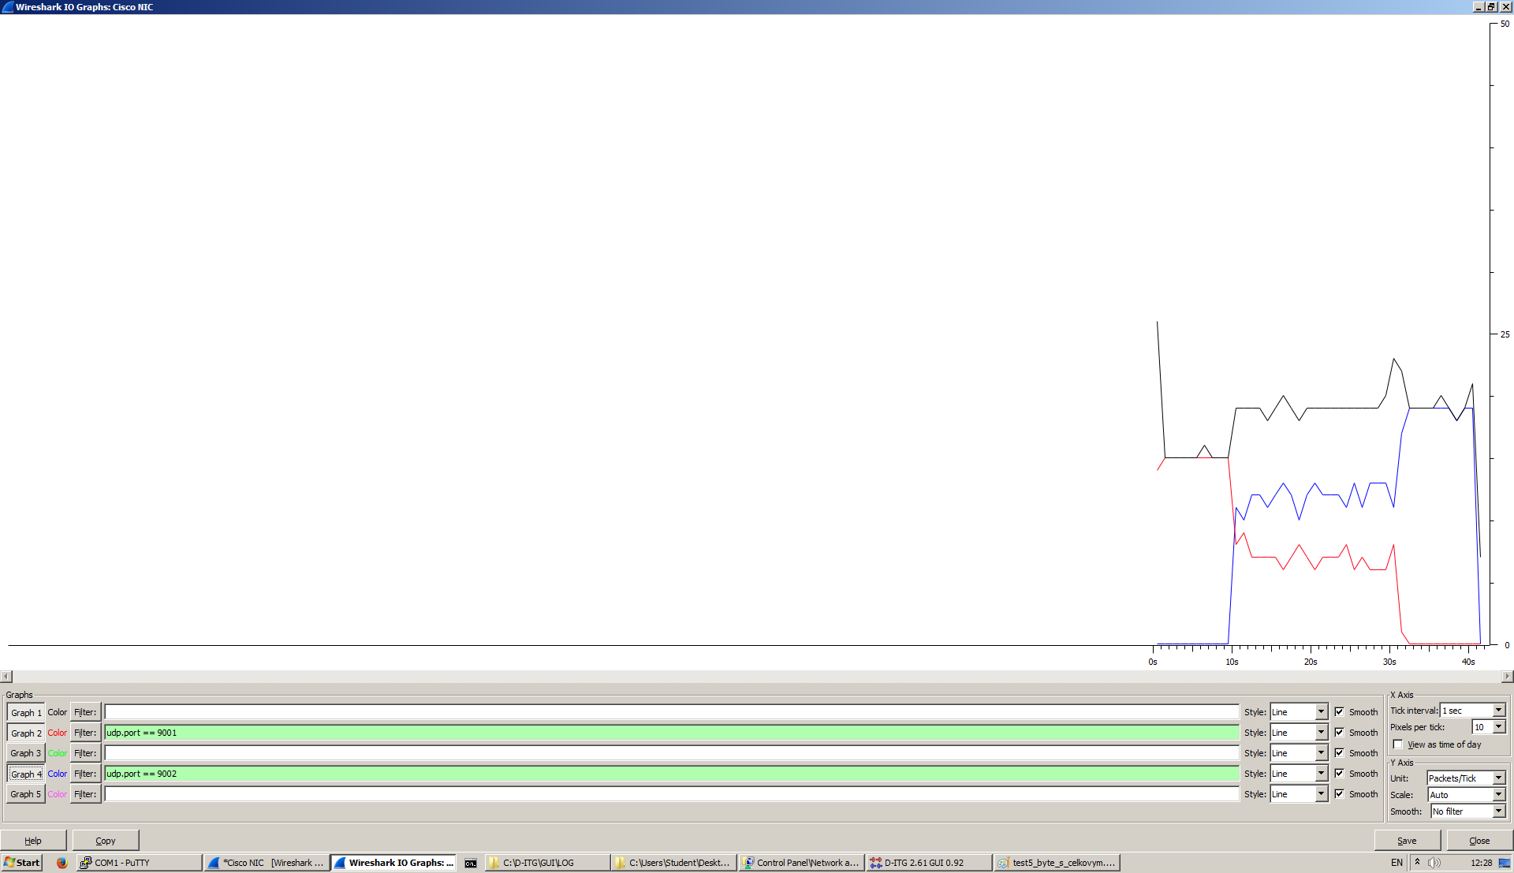

----------------------------------------------------------

Flow number: 1

From 10.0.1.2:63913

To 10.0.2.2:9001

----------------------------------------------------------

Total time = 30.149000 s

Total packets = 291

Minimum delay = -19.290000 s

Maximum delay = -18.246000 s

Average delay = -18.830873 s

Average jitter = 0.011179 s

Delay standard deviation = 0.490124 s

Bytes received = 232800

Average bitrate = 61.773193 Kbit/s

Average packet rate = 9.652061 pkt/s

Packets dropped = 147 (33.56 %)

Average loss-burst size = 2.161765 pkt

----------------------------------------------------------

Flow number: 2

From 10.0.1.2:63914

To 10.0.2.2:9002

----------------------------------------------------------

Total time = 30.042000 s

Total packets = 420

Minimum delay = -19.260000 s

Maximum delay = -18.246000 s

Average delay = -18.323831 s

Average jitter = 0.009317 s

Delay standard deviation = 0.133808 s

Bytes received = 336000

Average bitrate = 89.474735 Kbit/s

Average packet rate = 13.980427 pkt/s

Packets dropped = 162 (27.84 %)

Average loss-burst size = 1.862069 pkt

__________________________________________________________

**************** TOTAL RESULTS ******************

__________________________________________________________

Number of flows = 2

Total time = 40.027000 s

Total packets = 711

Minimum delay = -19.290000 s

Maximum delay = -18.246000 s

Average delay = -18.531354 s

Average jitter = 0.011421 s

Delay standard deviation = 0.413585 s

Bytes received = 568800

Average bitrate = 113.683264 Kbit/s

Average packet rate = 17.763010 pkt/s

Packets dropped = 309 (30.29 %)

Average loss-burst size = 1.993548 pkt

Error lines = 0

----------------------------------------------------------